General Biology Year 11 2023


Unit 1 - Classification and cell processes
Task 1: Practical – Using a dichotomous key to identify organisms
(weighting 5%)
MARKING KEY
Name: | Teacher: | Date: | Score:  / 22

The development and use of dichotomous keys make identification and communication easier and more accurate and also reflects evolutionary relationships. A dichotomy is the division of a group into smaller sub-groups. Each group contains members that share one characteristic. There are many characteristics that may be used but the most practical is anatomical structure.

Lake Richmond is a freshwater lake in Rockingham, Western Australia.

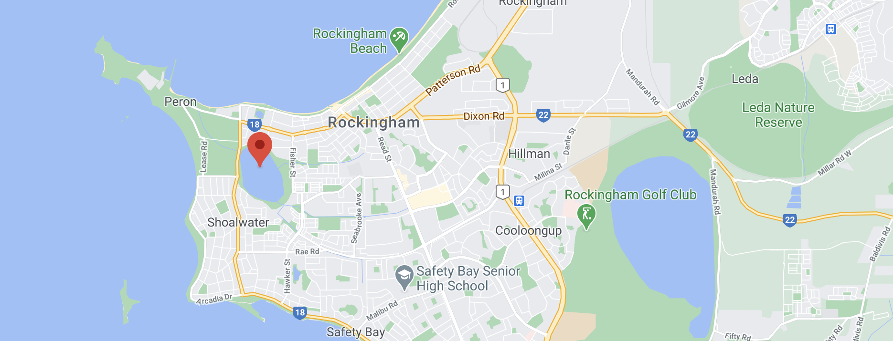
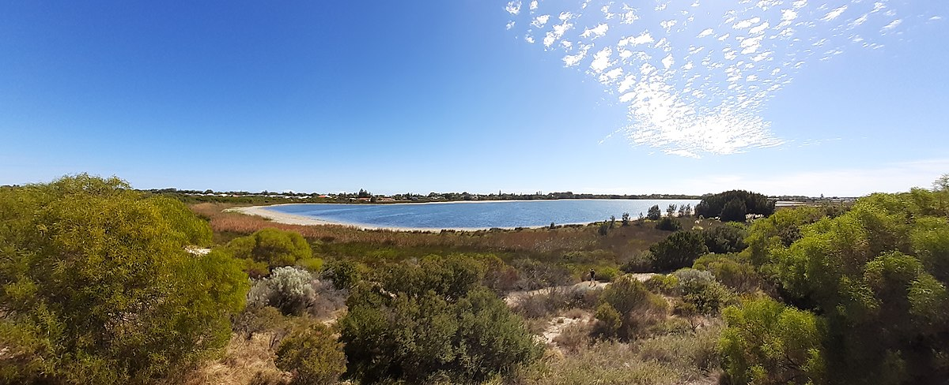
The Australian pelican, black swan, Australian shelduck, musk duck, white-faced heron and common greenshank are among the waterbirds that populate the 40-hectare, 15-metre-deep Lake Richmond.
The dome-shaped thrombolites of Lake Richmond are built by microorganisms that resemble the earliest life on Earth—a factor which has helped scientists unravel the secrets of how life began on the planet. Some 3,500 million to 650 million years ago, such organisms were the only known life forms on Earth and the thrombolites and stromatolites they constructed dominated the clear, shallow seas of this period, forming extensive reef tracts rivalling those of modern coral reefs. Today these once-dominant organisms are restricted to just a few places.
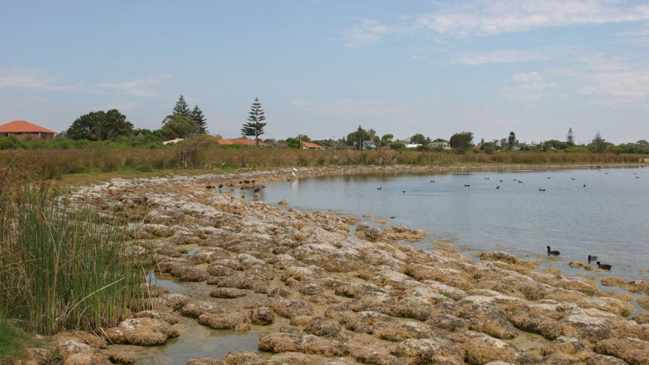

TASK

Follow the information provided to answer the following problems.

- Look at the illustrations of aquatic organisms found in our local area.

Group A Aquatic Organisms
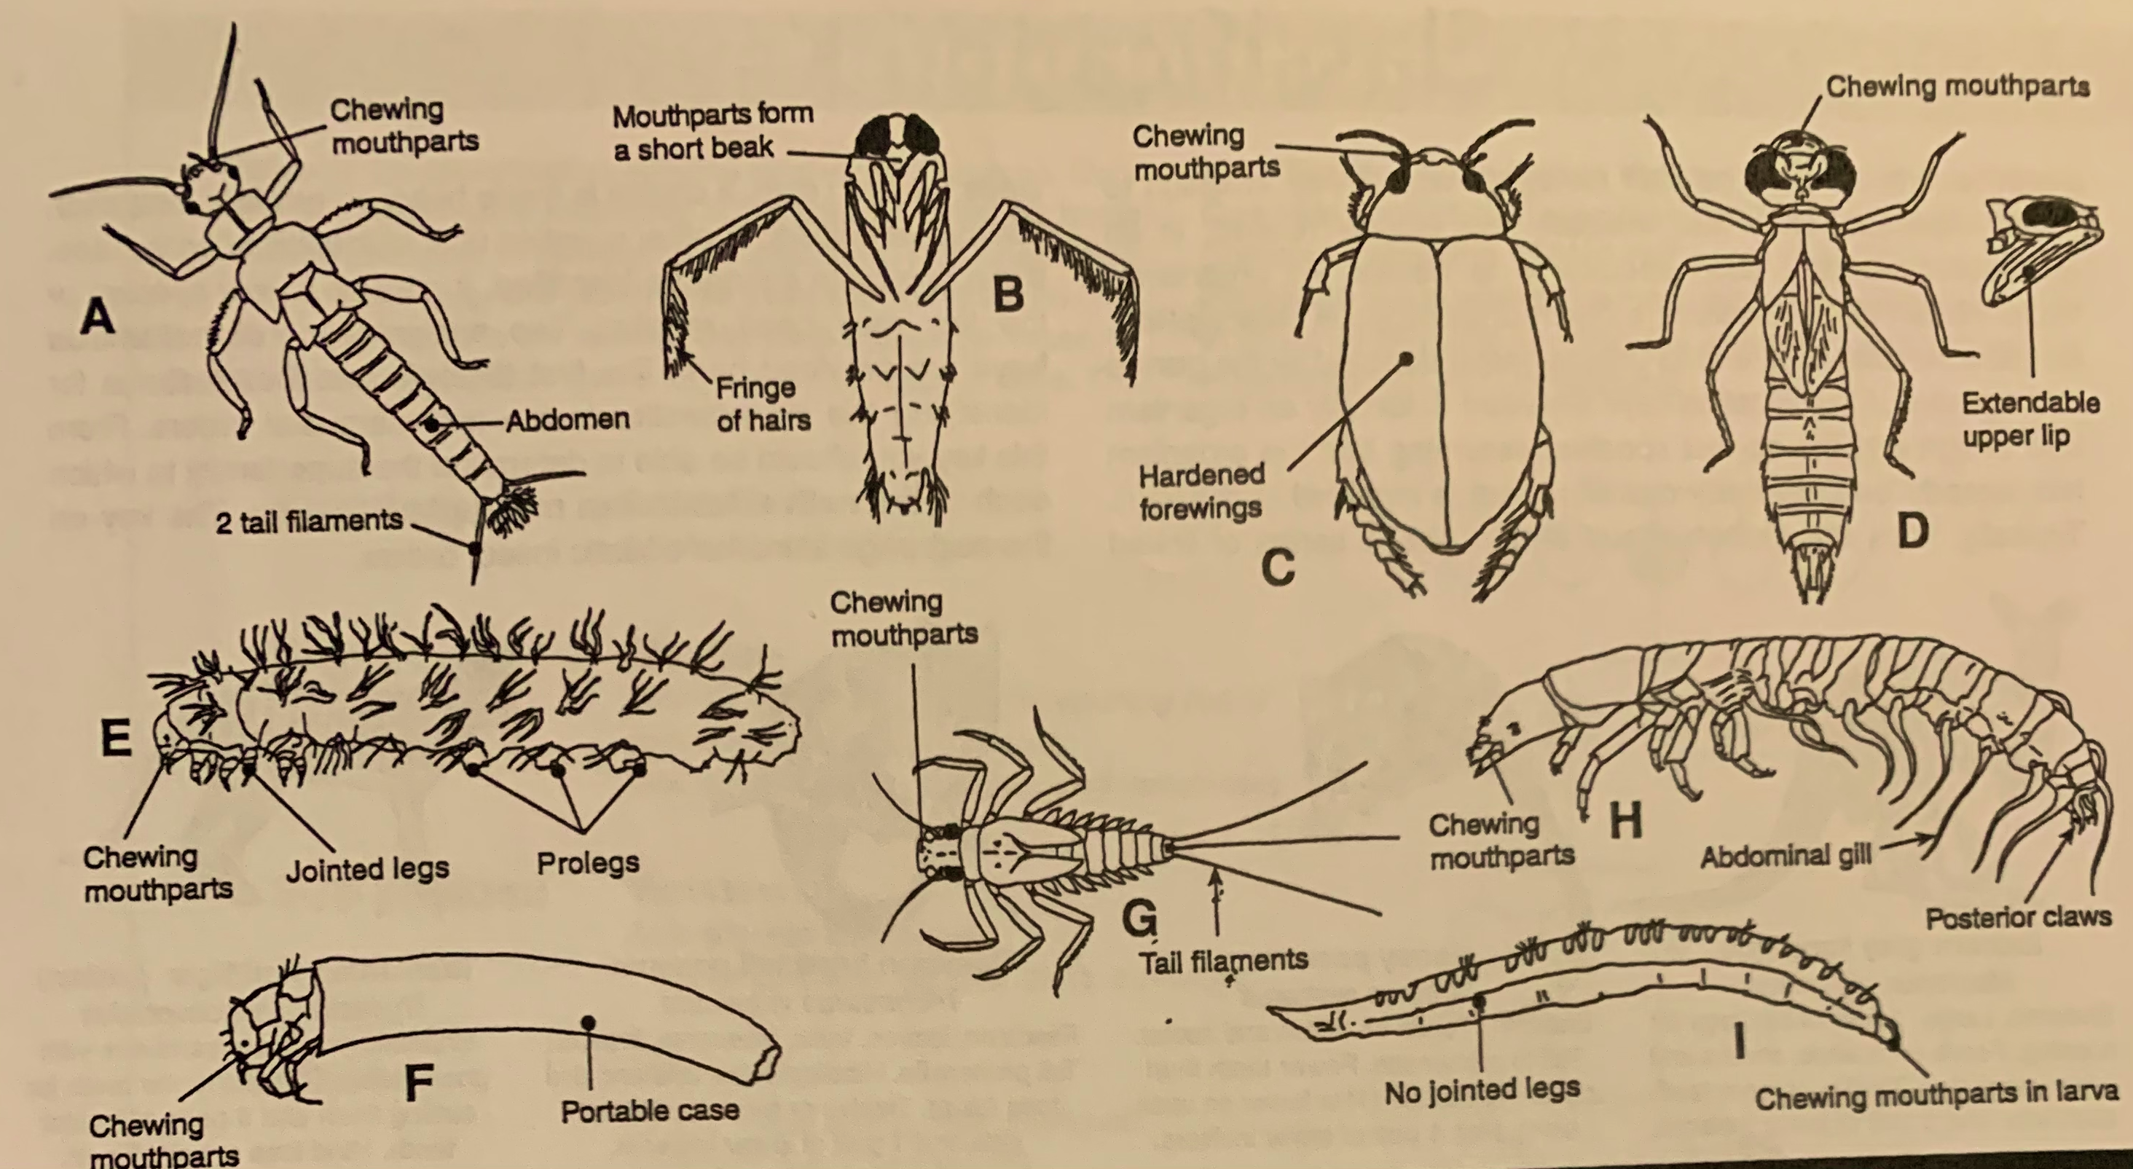

Any creditable characteristic to be valid.
1 mk for each grouping correctly titled and listed organisms (total 6 marks, all must be present for full marks)
-1 mk for each missing organism
-1 mk for each incorrect grouping
All Organisms
A, B, C, D, E, F, G, H, I
A & B

No tail filaments
B, C, D, E, F & I
A & B
Tail filaments
A & G

Two or less tail filaments
A
No jointed legs
I
Three or more tail filaments
G

Jointed legs
B, C, D, E, F & H
A & B

No wings
B, E, H & F
Wings
C & D
A & B

No abdominal gill
B, E & F
Abdominal gill
H
Hardened wings
C
No hardened wings
D
A & B

Small eyes
E & F
Large eyes
B

Antennae
A
No antennae
B & D
No portable case
E
Portable case
F

Long abdomen
D
No long abdomen
B

- In the branching key below, separate the aquatic organisms into two groups. All the organisms in one group will share one characteristic while the organisms in the second group will not have that characteristic.

Organisms with tail filaments in one group, organisms without tail filaments in the second group.
All Organisms

No tail filaments
________________________________________________________
Tail filaments
____________________________________________________

- Using the organism cards, complete the branching key by creating a dichotomous key. Fill out the empty part of the tree by writing in the text boxes, write in the characteristic that you would use at each dichotomy, then the list of organisms that belong in each box. You will need to resize the boxes, add additional boxes and arrows. (6 marks)

- Look at aquatic organisms in Group B below.

Group B Aquatic Organisms
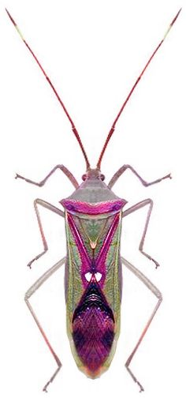

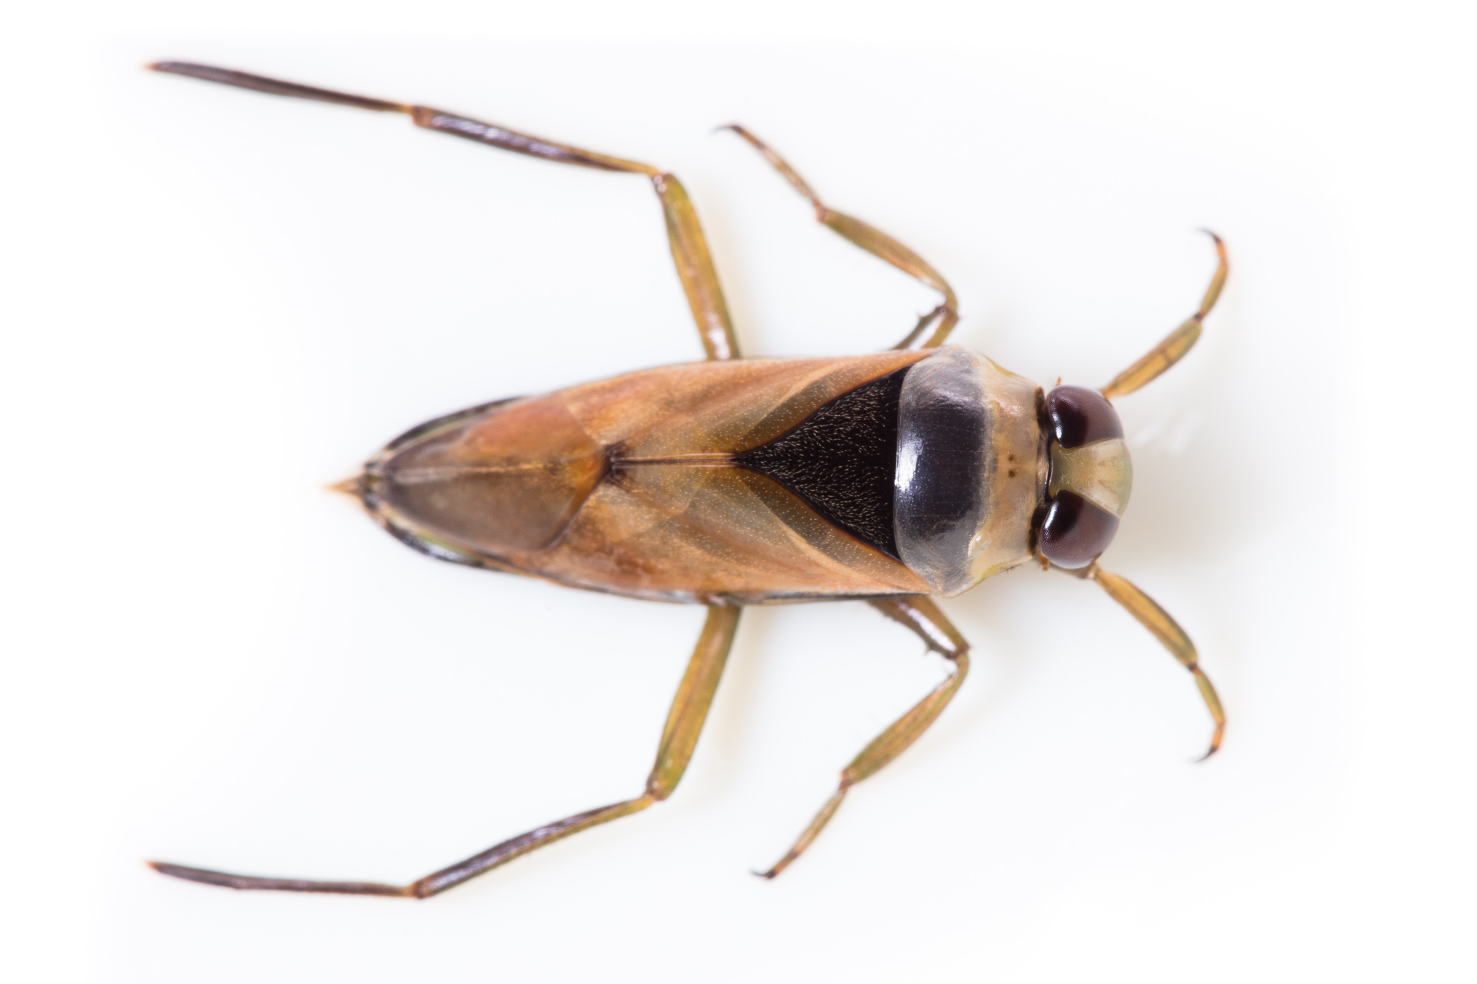

A B

- Try to use your key to identify them. Using a different colour pen add Group B organisms to your key. (2 marks)
________________________________________________________________________________________________________________________________________________________________________________________________________________________________________________
Refer to red grouping on key
1 mk for placing organisms in existing boxes

- How would you need to modify your key to include Organism A in the All Organisms group? (2 marks)
________________________________________________________________________________________________________________________________________________________________________________________________________________________________________________
Refer to red grouping on key
1 mk for each grouping listed correctly with title of
characteristic and organism

- Now complete the compact, numbered key below using the same organisms from Group A. You need to add extra numbers as you go: (5 marks)

1a Organisms with tail filaments Go to q2
1b Organisms without tail filaments Go to q
2a
2b
3a
3b
4a
4b

5 marks total

1 mk all organisms listed
1 mk matching branching key
1 mks for numbers in order
2 mks for key set up (1/2 numbers, ½ characteristics, ½ go to questions, ½ easy to follow)

- Which of the two keys (compact & numbered) do you find easier to use? Explain why. (2.5 marks)
________________________________________________________________________________________________________________________________________________________________________________________________________________________________________________
½ mk for stating the one that is easier to use
Easier to follow. 1 mk
Compacted to take up less
Space compared to a branching key. 1 mk

- Use the simplified key below to identify each of the orders (by order or common name) of aquatic insects in Group A Aquatic Organisms. (4.5 marks)

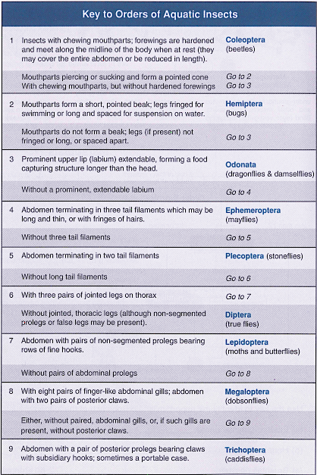

- Order of insect A ______________________________Plecoptera
- Order of insect B ______________________________Hemiptera
- Order of insect C ______________________________Coleoptera
- Order of insect D ______________________________Odonata
- Order of insect E ______________________________Lepidotera
- Order of insect F ______________________________Tricopthera
- Order of insect G ______________________________Ephemoptera
- Order of insect H ______________________________Megaloptera
- Order of insect I ______________________________Diptera

GROUP A

GROUP B

